**JS Quiz with answers**

1. What is JavaScript?

a) JavaScript is a scripting language used to make the website interactive

b) JavaScript is an assembly language used to make the website interactive

c) JavaScript is a compiled language used to make the website interactive

d) None of the mentioned

Answer: a

Explanation: JavaScript is a scripting language used along with HTML and CSS to make the website interactive along. It is used both on the client-side and server-side.

2. Which of the following is correct about JavaScript?

a) JavaScript is an Object-Based language

b) JavaScript is Assembly-language

c) JavaScript is an Object-Oriented language

d) JavaScript is a High-level language

Answer: a

Explanation: Although JavaScript is not an OOP (Object-Oriented Programming) language like Java or PHP, it is object based language. The standard threesome of polymorphism, encapsulation, and inheritance are the criteria for object orientation, and JavaScript fails to meet them.

3. Among the given statements, which statement defines closures in JavaScript?

a) JavaScript is a function that is enclosed with references to its inner function scope

b) JavaScript is a function that is enclosed with references to its lexical environment

c) JavaScript is a function that is enclosed with the object to its inner function scope

d) None of the mentioned

Answer: b

Explanation: A closure is a function that is enclosed with references to its lexical environment. A closure allows an inner function to access the scope of an outside function. Closures are formed every time a function is created in JavaScript, during function creation time.

4. What will be the output of the following JavaScript code snippet?

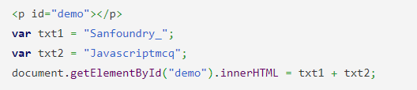

a) error

b) Sanfoundry_ Javascriptmcq

c) undefined

d) Sanfoundry_Javascriptmcq

Answer: d

Explanation: The + operator in javascript acts as a concatenation operator when used with string. The new string does not have any space between the two added strings.

5. What will be the output of the following JavaScript code?

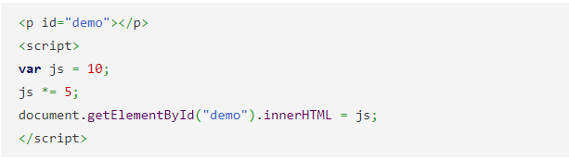

a) 10

b) 50

c) 5

d) Error

Answer: b Explanation: The *= operator in javascript is a shorthand expression for the multiplication of a particular number. It is a combination of two operators * and =

6. Arrays in JavaScript are defined by which of the following statements?

a) It is an ordered list of values

b) It is an ordered list of objects

c) It is an ordered list of string

d) It is an ordered list of functions.

Answer: a

Explanation: An array in JavaScript is an ordered list of values, each value is referred to as an element, and it is identified by an index. An array can include values of many sorts and the length of an array dynamically sized.

7. What will be the output of the following JavaScript code?

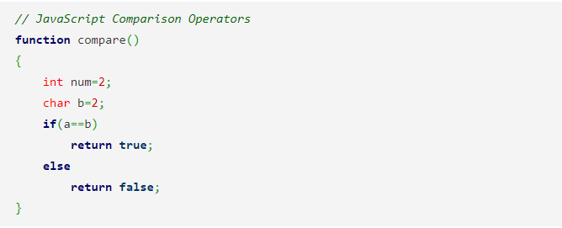

a) false

b) true

c) compilation error

d) runtime error

Answer: b

Explanation: The == in JS convert different types of operands to the same type before making the comparison. A strict comparison results in true value if the operands are of the same type and the contents match.

8. What will be the output of the following JavaScript code snippet?

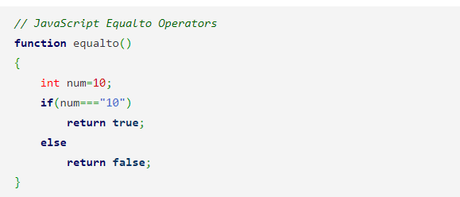

a) false

b) true

c) compilation error

d) runtime error

Answer: a

Explanation: A === operator in JS is only true if the operands are of the same type and the contents match. Two strings are strictly equal when they have the same sequence of characters, same length, and same characters in corresponding positions.

9. Will the following JavaScript code work?



a) Exception will be thrown

b) Memory leak

c) Error

d) Yes, perfectly

Answer: d

Explanation: For functions expressed as expressions, the function name is optional in Javascript. Sometimes function expressions are defined and used right away.

10. Which of the following is not javascript data types?

a) Null type

b) Undefined type

c) Number type

d) All of the mentioned

Answer: d

Explanation: JavaScript is a dynamic, loosely typed language. Variables in JavaScript aren’t tied to any specific value type, and each variable can be assigned and reassigned to values of all the types.

11. Where is Client-side JavaScript code is embedded within HTML documents?

a) A URL that uses the special javascript:code

b) A URL that uses the special javascript:protocol

c) A URL that uses the special javascript:encoding

d) A URL that uses the special javascript:stack

Answer: b

Explanation: The Client-side JavaScript code is embedded within HTML documents in four ways :

1. Inline, between a pair of “script” tags
2. From an external file specified by the src attribute of a “script” tag
3. In an HTML event handler attribute, such as onclick or onmouseover
4. In a URL that uses the special javascript: protocol.

12. What will be the output of the following JavaScript code snippet?

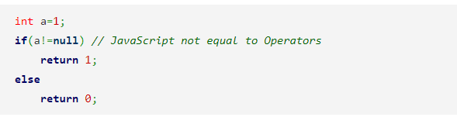a) 0

b) 1

c) compiler error

d) runtime error

Answer: b

Explanation: != is not equal to the operator in Javascript. It gives a value of 1 if the two values which are compared are not equal and give 0 if the two values are equal.

13. Which of the following object is the main entry point to all client-side JavaScript features and APIs?

a) Position

b) Window

c) Standard

d) Location

Answer: b

Explanation: All client-side JavaScript features and APIs are accessed through the Window object. It represents a web browser window or frame, and the identifier window can be used to refer to it.

14. What will be the output of the following JavaScript program?

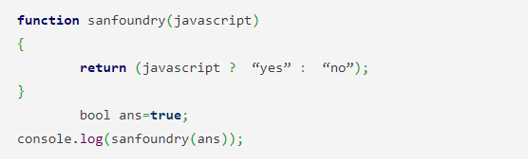

a) Compilation error

b) Runtime error

c) Yes

d) No

Answer: c

Explanation: In javascript, “?” is called the ternary operator which is used for choosing one choice from the given two choices. It is used instead of if else statement and makes the code shorter.

15. What will be the output of the following JavaScript code?

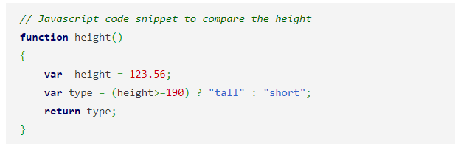

a) short

b) 123.56

c) tall

d) 190

Answer: a

Explanation: The ternary operator in javascript is used as a comparison operator which works on three operands. The statement in the above code initializes type variable with the value short which is returned through the function.

16. Which of the following can be used to call a JavaScript Code Snippet?

a) Function/Method

b) Preprocessor

c) Triggering Event

d) RMI

Answer: a

Explanation: A function call to the element on which JavaScript is to be run can be used to invoke JavaScript code. Other techniques include onclick, onload, and onsubmit, among others.

17. What will be the output of the following JavaScript function?

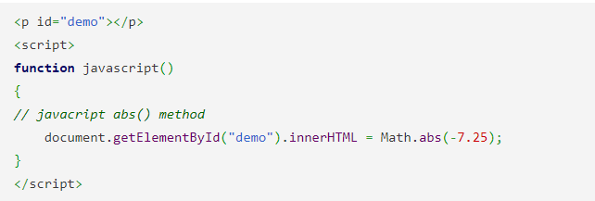

a) -7.25

b) 7.25

c) -7

d) 7

Answer: b

Explanation: The javacript abs() method returns the absolute value of a number. The method is found in the math library of Javascript.

18. What will be the output of the following JavaScript code?

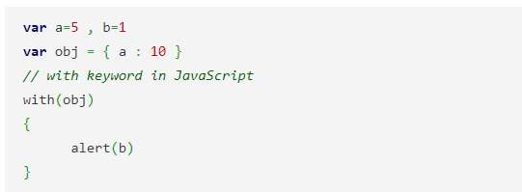

a) 1

b) 10

c) 5

d) Error

Answer: a

Explanation: Firstly the interpreter checks obj for property b. But it doesn’t find any property b so it takes the value from outside the object within the JavaScript code snippet.

19. Which of the following explains correctly what happens when a JavaScript program is developed on a Unix Machine?

a) will work perfectly well on a Windows Machine

b) will be displayed as JavaScript text on the browser

c) will throw errors and exceptions

d) must be restricted to a Unix Machine only

Answer: a

Explanation: Because JS can run on a variety of operating systems, an application written for UNIX will run just as well on Windows.

20. Which is a more efficient JavaScript code snippet?

Code 1 :

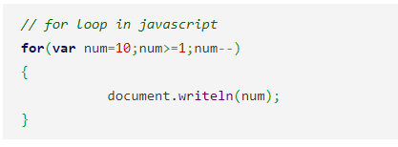

Code 2 :

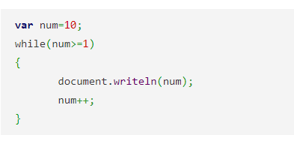

a) Code 1

b) Code 2

c) Both Code 1 and Code 2

d) Cannot Compare

Answer: a

Explanation: Code 1 would be more efficient JS code. Infact second code will go into runtime error as the value of num will never reach less than or equal to one.

21. What will be the output of the following JavaScript code?

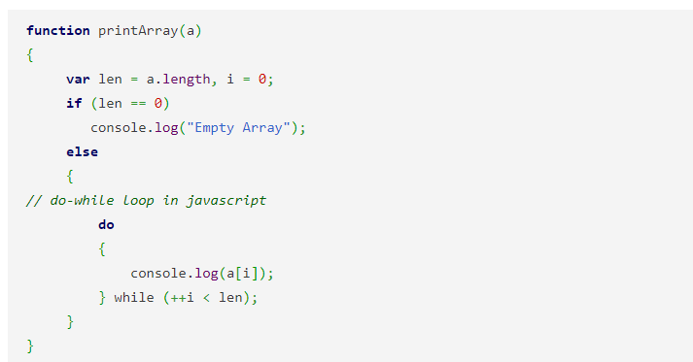

a) Prints “Empty Array”

b) Prints 0 to the length of the array

c) Prints the numbers in the array in order

d) Prints the numbers in the array in the reverse order

Answer: c

Explanation: The do/while statement creates a loop that executes a block of javascript code once, before checking if the condition is true, then it will repeat the loop as long as the condition is true. Hence the iterator traverses through the array and print them in normal order.

22. What happens in the following JavaScript code snippet?

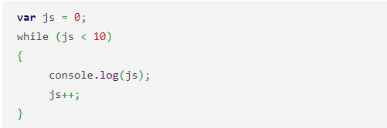

a) An exception is thrown

b) The values of js are logged or stored in a particular location or storage

c) The value of js from 0 to 9 is displayed in the console

d) An error is displayed

Answer: c

Explanation: In JavaScript, Console.log is a predefined function that accepts the value as an argument. At the time of code execution, console.log prints this value in the argument to the console.

23. What will be the output of the following JavaScript code?

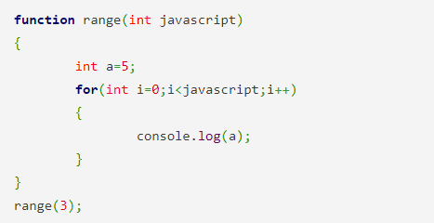

a) 2

b) 5

c) 555

d) error

Answer: c

Explanation: for loop in Javascript first initializes the variable and later on checks for the condition expression and after that execute the line of statements. The value of iterator i increase until it reaches the value of length.

24. Which of the following scoping type does JavaScript use?

a) Sequential

b) Segmental

c) Lexical

d) Literal

Answer: c

Explanation: JavaScript, like most current programming languages, employs lexical scoping. This means that functions are performed with the variable scope in effect when they were defined, rather than the variable scope in effect when they are invoked.

25. What is the basic difference between JavaScript and Java?

a) Functions are considered as fields

b) Functions are values, and there is no hard distinction between methods and fields

c) Variables are specific

d) There is no difference

Answer: b

Explanation: Java is an object-oriented programming language, while JS is an object-oriented scripting language. The main difference between JavaScript and Java is that functions are values, while methods and fields are not clearly defined.

26. What will be the output of the following JavaScript code?

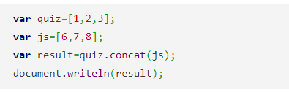

a) 1, 2, 3, 6, 7, 8

b) 123

c) 1, 2, 3

d) Error

Answer: a

Explanation: concat is a predefined function in the array library in Javascript. The concat function is used to combine the value of two arrays.

i.e.1, 2, 3, 6, 7, 8

27. Why JavaScript Engine is needed?

a) Both Compiling & Interpreting the JavaScript

b) Parsing the javascript

c) Interpreting the JavaScript

d) Compiling the JavaScript

Answer: c

Explanation: For the most part, the JS Engine is used to interpret JavaScript. It’s used to parse javascript and run it on a web page.

28. What will be the function of the following JavaScript program?

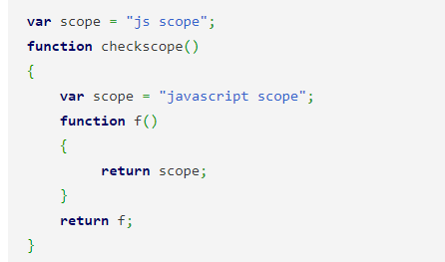

a) Returns the value in scope

b) Returns value null

c) Shows an error message

d) Returns exception

Answer: a

Explanation: The Lexical Environment is an object that is connected with every executing function, code block, and the script as a whole in JavaScript. The value in scope is returned by the code snippet above.

29. What will be the output of the following JavaScript code?

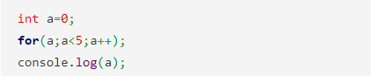

a) 4

b) 5

c) 0

d) error

Answer: b

Explanation: The value of a will increase until it equals 5, at which point the cursor will exit the loop. Because there are no statements in the for loop, the value of a will only increase. As a result, the result will be five.

30. Which of the following methods/operation does javascript use instead of == and !=?

a) JavaScript uses equalto()

b) JavaScript uses equals() and notequals() instead

c) JavaScript uses bitwise checking

d) JavaScript uses === and !== instead

Answer: d

Explanation: The comma operator, bitwise operators, and the ++ and — operators are not included in the subset. It also forbids the usage of == and!= due to the type conversion they do, instead requiring the use of === and!==.

31. What will be the result or type of error if p is not defined in the following JavaScript code snippet?



a) Value not found Error

b) Reference Error

c) Null

d) Zero

Answer: b

Explanation: Console.log() is a javascript predefined function for printing data or messages to the console. A reference error will occur if the console.log argument is not defined.

32. What is the prototype represents in the following JavaScript code snippet?



a) Not valid

b) Prototype of a function

c) Function javascript

d) A custom constructor

Answer: d

Explanation: All object instances have a constructor property that points to the constructor function that created them. A custom constructor is a constructor which requires no arguments and is created automatically by the compiler at the time of object creation if not created by the user.

33. Why event handlers is needed in JS?

a) Allows JavaScript code to alter the *behaviour* of windows

b) Adds innerHTML page to the code

c) Change the server location

d) Performs handling of exceptions and occurrences

Answer: a

Explanation: JS code can change the *behavior* of windows, documents, and the elements that make up those documents via event handlers.

34. Which of the following is not a framework?

a) JavaScript .NET

b) JavaScript

c) Cocoa JS

d) jQuery

Answer: b

Explanation: jQuery, which is used in web development, is one of the most popular frameworks. JavaScript is a scripting language, not a framework, in this case.

35. Which of the following is the property that is triggered in response to JS errors?

a) onclick

b) onerror

c) onmessage

d) onexception

Answer: b

Explanation: The Window object’s **onerror** property acts as an event handler, and it is triggered when JavaScript problems occur. However, because it is called with various arguments, it isn’t a genuine event handler.

36. What will be the output of the following JavaScript code?

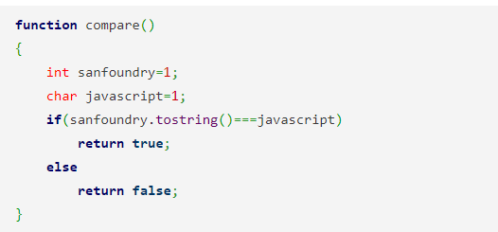

a) runtime error

b) logical error

c) true

d) false

Answer: c

Explanation: The .tostring() function can be used to convert a non-string (integer) to a string. Only if the operands are of the same type and the contents match is a rigorous comparison possible. As a result, the following code line will produce true output.

37. What will be the firstname and surname of the following JavaScript program?

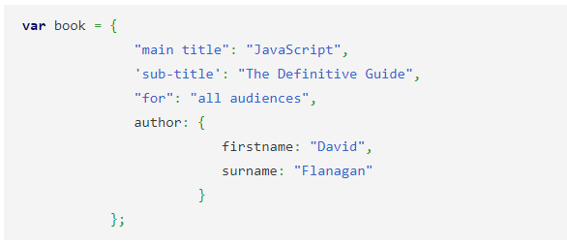

a) objects

b) property names

c) properties

d) property values

Answer: b

Explanation: An item is contained within another object in the code sample above. The property names are firstname and surname. The value of that property is an object in and of itself.

38. Which of the following is not an error in JavaScript?

a) Missing of Bracket

b) Division by zero

c) Syntax error

d) Missing of semicolons

Answer: b

Explanation: In JavaScript, division by zero does not result in an error; it just returns infinity or negative infinity. However, because zero divided by zero has no well-defined value, the result of this operation is the unusual not-a-number value, which is written as NaN.

39. Consider the following JavaScript statement containing regular expressions and check if the pattern matches.

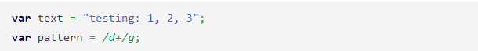

a) text.check(pattern)

b) pattern.test(text)

c) text==pattern

d) text.equals(pattern)

Answer: b

Explanation: The pattern specified is applied to the text included in parenthesis. The test() method checks a string for a match. If a match is found, this method returns true; otherwise, it returns false.

40. The web development environment (JavaScript) offers which standard construct for data validation of the input entered by the user.

a) Controlled loop constructs

b) Server page access

c) Client side Event

d) Permit server-side

Answer: a

Explanation: JavaScript provides with for, while loops and if, else, switch cases for checking the information entered by the user. Additionally, all development environments provide syntax to create and use memory variables, constants, and functions.

41.The main purpose of a “Live Wire” in NetScape is to ________

a) Create linkage between client side and server side

b) Permit server side, JavaScript code, to connect to RDBMS

c) Support only non relational database

d) To interpret JavaScript code

Answer: b

Explanation: A Live Wire database driver also supports a number of non-relational databases.

42.The script tag must be placed in __________

a) the head tag

b) the head or body

c) the title or head

d) after the body tag

Answer: b

Explanation: If the script tag is placed after the body tag, then, it will not be evaluated at all. Also, it is always recommended and effective to use the script snippet in the <head> tag.

43. A JavaScript program developed on a Unix Machine ________

a) will throw errors and exceptions

b) must be restricted to a Unix Machine only

c) will work perfectly well on a Windows Machine

d) will be displayed as a JavaScript text on the browser

Answer: c

Explanation: JavaScript can be executed on different operating systems therefore the program developed on UNIX will work perfectly fine on windows also.

44. JavaScript is ideal to ________

a) make computations in HTML simpler

b) minimize storage requirements on the web server

c) increase the download time for the client

d) increase the loading time of the website

Answer: b

Explanation: JavaScript helps in performing various tasks with minimum storage requirements. Therefore to minimize storage requirements, JavaScript is always a better say.

45.Which of the following Attribute is used to include External JS code inside your HTML Document?

a) src

b) ext

c) script

d) link

Answer: a

Explanation: Script “tag” is used to include the JavaScript code. To include external JavaScript files “src” attribute is used inside the script tag.

46.A proper scripting language is a __________

a) High level programming language

b) Assembly level programming language

c) Machine level programming language

d) Low level programming language

Answer: a

Explanation: JavaScript is a high-level programming language that is interpreted by another program at runtime rather than compiled by the computer’s processor. Scripting languages, which can be embedded within HTML, commonly are used to add functionality to a Web page, such as different menu styles or graphics displays or to serve dynamic advertisements.

47. What will be the output of the following JavaScript code?

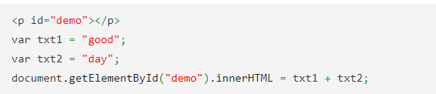

a) good day

b) goodday

c) error

d) undefined

Answer: b

Explanation: The + operator acts as a concatenation operator when used with string. The new string does not have any space between the two added string.

48. What will be the output of the following JavaScript code?

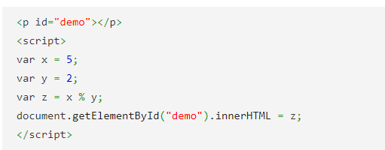

a) 0

b) 1

c) 2

d) 5

Answer: b

Explanation: The % operator returns the remainder between the two numbers. It is used many times with if condition to check whether the number is divisible or not.

49. What will be the output of the following JavaScript code?

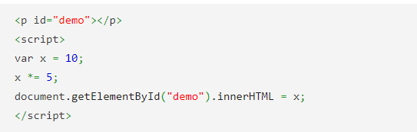

a) 5

b) 10

c) 50

d) Error

Answer: c

Explanation: The *= operator is a shorthand expression for multiplication of a particular number. It is a combination of two operators * and = .

50. What will be the output of the following JavaScript code?

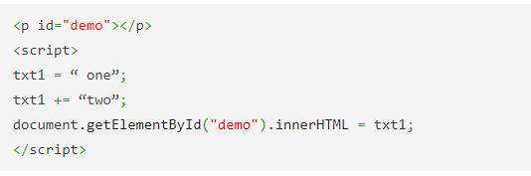

a) onetwo

b) one two

c) error

d) undefined

Answer: a

Explanation: The += operator acts in the same way as the concatenation operator in the string. There is no space added when two string are added together with += operator.

51. What will be the output of the following JavaScript code?

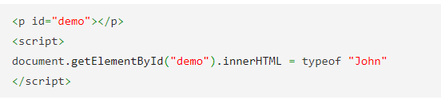

a) integer

b) number

c) string

d) error

Answer: c

Explanation: The typeof operator returns the type of the argument passed to it. The typeof operator returns number for an integer and string for a character array.

52. The type of a variable that is volatile is _______________

a) Volatile variable

b) Mutable variable

c) Immutable variable

d) Dynamic variable

Answer: b

Explanation: The variables whose values can be changed are called mutable variable types. In JavaScript, only objects and arrays are mutable, not primitive values.

53. A hexadecimal literal begins with __________

a) 00

b) 0x

c) 0X

d) Both 0x and 0X

Answer: d

Explanation: Generally, X or x denotes hexadecimal values. So, any integer literal that begins with 0X or 0x denotes a hexadecimal number.

54. JavaScript _________ when there is an indefinite or an infinite value during an arithmetic computation.

a) Prints an exception error

b) Prints an overflow error

c) Displays “Infinity”

d) Prints the value as such

Answer: c

Explanation: When the result of a numeric operation is larger than the largest representable number (overflow), JavaScript prints the value as Infinity. Similarly, when a negative value becomes larger than the largest representable negative number, the result is negative infinity. The infinite values behave as you would expect: adding, subtracting, multiplying, or dividing them by anything results in an infinite value (possibly with the sign reversed).

55. Which of the following is not considered as an error in JavaScript?

a) Syntax error

b) Missing of semicolons

c) Division by zero

d) Missing of Bracket

Answer: c

Explanation: Division by zero is not an error in JavaScript: it simply returns infinity or negative infinity. There is one exception, however: zero divided by zero does not have a well defined value, and the result of this operation is the special not-a-number value, printed as NaN.

56. The escape sequence ‘\f’ stands for _________

a) Floating numbers

b) Representation of functions that returns a value

c) \f is not present in JavaScript

d) Form feed

Answer: d

Explanation: \f is the JavaScript escape sequence that stands for Form feed (\u000C). It skips to the start of the next page. (Applies mostly to terminals where the output device is a printer rather than a VDU).

57. The snippet that has to be used to check if “a” is not equal to “null” is _________

a) if(a!=null)

b) if (!a)

c) if(a!null)

d) if(a!==null)

Answer: d

Explanation: A strict comparison (e.g., ===) is only true if the operands are of the same type and the contents match. The more commonly-used abstract comparison (e.g. ==) converts the operands to the same type before making the comparison. The not-equal operator !== compares 0 to null and evaluates to either true or false

58. The statement a===b refers to _________

a) Both a and b are equal in value, type and reference address

b) Both a and b are equal in value

c) Both a and b are equal in value and type

d) There is no such statement.

Answer: c

Explanation: ”===” operator is known as the strict comparison operator. A strict comparison (===) is only true if the operands are of the same type and the contents match.

59. Assume that we have to convert “false” that is a non-string to string. The command that we use is (without invoking the “new” operator).

a) false.toString()

b) String(false)

c) String newvariable=”false”

d) Both false.toString() and String(false)

Answer: d

Explanation: The three approaches for converting to string are: value.toString(),”” + value and String(value). A non-string can be converted in two ways without using a new operator false.toString () and String(false).

60. What will be the output of the following JavaScript code?

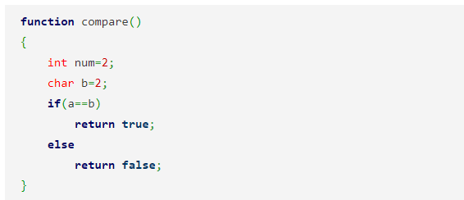

a) true

b) false

c) runtime error

d) compilation error

Answer: a

Explanation: The == convert different type of operands to the same type before making the comparison. A strict comparison results into true value if the operands are of the same type and the contents match.

61. What will be the output of the following JavaScript code?

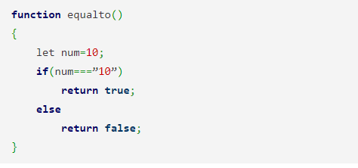

a) true

b) false

c) runtime error

d) compilation error

Answer: b

Explanation: A === operator is only true if the operands are of the same type and the contents match. Two strings are strictly equal when they have the same sequence of characters, same length, and same characters in corresponding positions.

62. What will be the output of the following JavaScript code?

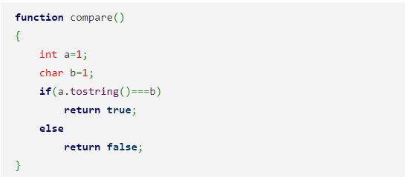

a) true

b) false

c) runtime error

d) logical error

Answer: a

Explanation: A non string (integer) can be converted to string using .tostring() function. A strict comparison is only true if the operands are of the same type and the contents match. Hence the following code snippet would result into true output.

63. What will be the output of the following JavaScript code?

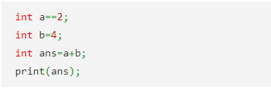

a) 2

b) 6

c) 0

d) error

Answer: d

Explanation: The following code will generate into an error output as a comparator operator is used outside of if statement. A single equalto (’=’) operator is used for initialization.

64. What will be the output of the following JavaScript code?

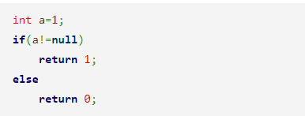

a) 1

b) 0

c) runtime error

d) compiler error

Answer: a

Explanation: != is the not equal to operator. It gives a value of 1 if the two values which are compared are not equal and give 0 if the two values are equal.

65. What will be the output of the following JavaScript code?

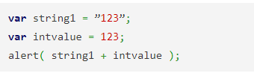

a) 123246

b) 246

c) 123123

d) Exception

Answer: c

Explanation: In JavaScript the alert function does the type casting and converts the integer value to string. After that it concatenates both the strings and shows the result as a concatenated string. Thus 123123 would be correct.

66. A function definition expression can be called as __________

a) Function prototype

b) Function literal

c) Function calling

d) Function declaration

Answer: b

Explanation: A function definition expression is a “function literal” in the same way that an object initializer is an “object literal.” A Function definition expression typically consists of the keyword function followed by a comma-separated list of zero or more identifiers (the parameter names) in parentheses and a block of JavaScript code (the function body) in curly braces.

67. The property of a primary expression is ____________

a) stand-alone expressions

b) basic expressions containing all necessary functions

c) contains variable references alone

d) contains only keywords

Answer: a

Explanation: The simplest expressions, known as primary expressions, are those that stand alone — they do not include any simpler expressions. Primary expressions in JavaScript are constant or literal values, certain language keywords, and variable references.

68. Consider the following JavaScript statements.

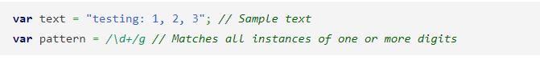

In order to check if the pattern matches with the string “text”, the statement is ____________

a) text==pattern

b) text.equals(pattern)

c) text.test(pattern)

d) pattern.test(text)

Answer: d

Explanation: The given pattern is applied on the text given in the parenthesis.

69. The expression of calling (or executing) a function or method in JavaScript is called ________

a) Primary expression

b) Functional expression

c) Invocation expression

d) Property Access Expression

Answer: c

Explanation: An invocation expression is JavaScript’s syntax for calling (or executing) a function or method). It starts with a function expression that identifies the function to be called.

70. What kind of expression is “new Point(2,3)”?

a) Primary Expression

b) Object Creation Expression

c) Invocation Expression

d) Constructor Calling Expression

Answer: b

Explanation: An object creation expression creates a new object and invokes a function (called a constructor) to initialize the properties of that object. Object creation expressions are like invocation expressions except that they are prefixed with the keyword new.

71. Which of the operator is used to test if a particular property exists or not?

a) in

b) exist

c) within

d) exists

Answer: a

Explanation: The operator “in” tests whether a particular property exists or not. In operator is usually added in looping statements to traverse the array or the object.

72. Among the following, which one is a ternary operator?

a) +

b) :

c) –

d) ?:

Answer: d

Explanation: JavaScript supports one ternary operator, the conditional operator ?:, which combines three expressions into a single expression. If else case can be replaced by the conditional operator

73. “An expression that can legally appear on the left side of an assignment expression.” is a well known explanation for variables, properties of objects, and elements of arrays. They are called ___________

a) Properties

b) Prototypes

c) Lvalue

d) Definition

Answer: c

Explanation: lvalue is a historical term that means “an expression that can legally appear on the left side of an assignment expression.” In JavaScript, variables, properties of objects, and elements of arrays are lvalues.

74. What will be the equivalent output of the following JavaScript code snippet?

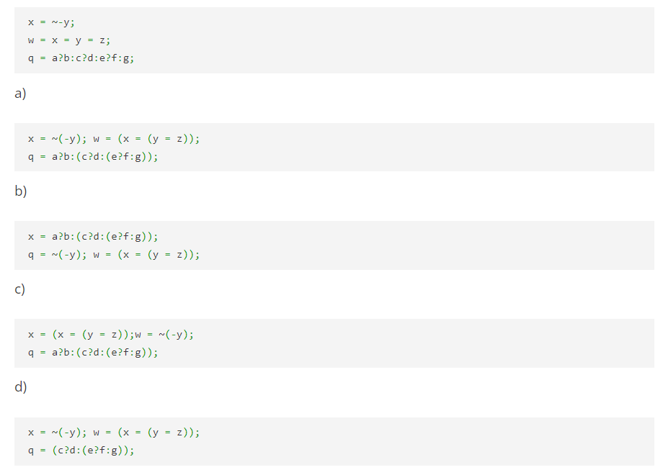

Answer: a

Explanation: Brackets have higher precedence than any other operator. The placement of brackets results in the same result as without putting any bracket.

75. What will be the output of the following JavaScript code?

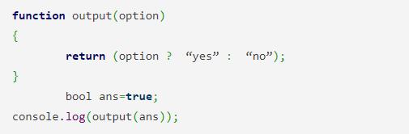

a) Yes

b) No

c) Runtime error

d) Compilation error

Answer: a

Explanation: “?” is called the ternary operator which is used for choosing one choice from the given two choices. It is used instead of if else statement and makes the code shorter.

76. What will be the output of the following JavaScript code?

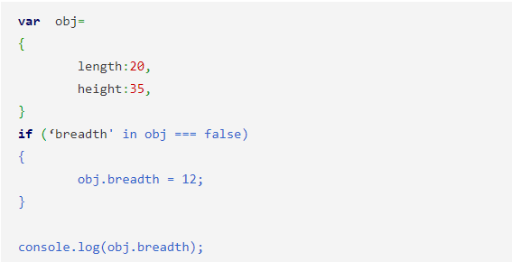

a) 20

b) 12

c) undefined

d) error

Answer: b

Explanation: The “in” operator checks for the presence of a particular property in object. It returns true if the property is present and returns false if the property is not present.

77. What will be the output of the following JavaScript code?

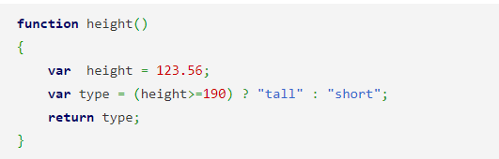

a) 123.56

b) 190

c) tall

d) short

Answer: d

Explanation: The ternery operator is used as a comparison operator which works on three operands. The statement in the above code initializes type variable with the value short which is returned through the function.

78. What will be the output of the following JavaScript code?

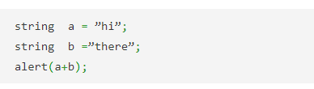

a) hi

b) there

c) hithere

d) undefined

Answer: c

Explanation: alert function is used to print the value passed as argument in a dialog box in a browser. The alert function adds both the string and prints the result as a combined string.

79. What will be the output of the following JavaScript code?

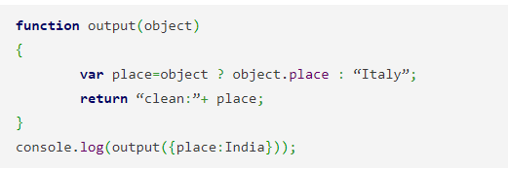

a) clean:India

b) clean:Italy

c) error

d) undefined

Answer: a

Explanation: ”?” operator is used to compare the values and place is initialized according to the true condition that whether it is true or false. The function is called in the console.log and the object value is passed.

80. What will be the output of the following JavaScript code?

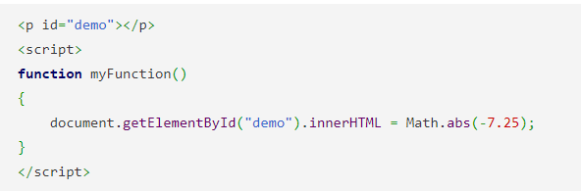

a) 7.25

b) -7.25

c) 7

d) -7

Answer: a

Explanation: The abs() method returns the absolute value of a number. The method is find in the math library of Javascript.

81. What will be the output of the following JavaScript code?

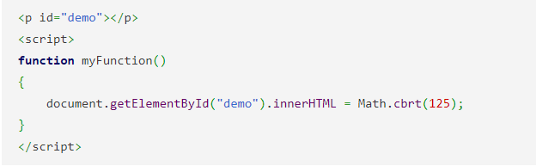

a) 125

b) 25

c) 5

d) Error

Answer: c

Explanation: cbrt return the cubic root of a number. The method is find in the math library of Javascript.

82. What will be the output of the following JavaScript code?

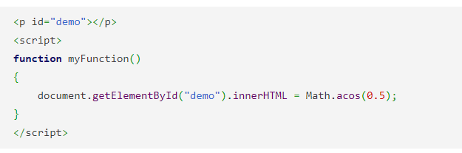

a) 1.01

b) 1.047

c) 1.00

d) 1.4

Answer: b

Explanation: The acos() method returns the arccosine of a number as a value value between 0 and PI radians. If the parameter x is outside the range -1 to 1, the method will return NaN.

83. A conditional expression is also called a _______________

a) Alternative to if-else

b) Immediate if

c) If-then-else statement

d) Switch statement

Answer: b

Explanation: A conditional expression can evaluate to either True or False based on the evaluation of the condition. If the condition is true then the value following the operator is taken that’s why it is called immediate if.

84. What is a block statement in JavaScript?

a) conditional block

b) block that contains a single statement

c) both conditional block and a single statement

d) block that combines multiple statements into a single compound statement

Answer: d

Explanation: A block statement groups zero or more statements. In languages other than JavaScript, it is known as a compound statement. A statement block is a block that combines more than one statements into a single compound statement for ease.

85. When an empty statement is encountered, a JavaScript interpreter __________

a) Ignores the statement

b) Prompts to complete the statement

c) Throws an error

d) Shows a warning

Answer: a

Explanation: The JavaScript interpreter takes no action when it executes an empty statement. The empty statement is occasionally useful when you want to create a loop that has an empty body.

7. The “var” and “function” are __________

a) Keywords

b) Declaration statements

c) Data types

d) Prototypes

Answer: b

Explanation: The var and function are declaration statements—they declare or define variables and functions. These statements define identifiers (variable and function names) that can be used elsewhere in your program and assign values to those identifiers.

86. In the following switch syntax, the expression is compared with the case labels using which of the following operator(s)?

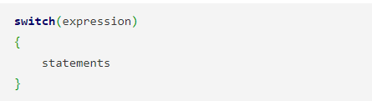

a) ==

b) equals

c) equal

d) ===

Answer: d

Explanation: A strict comparison (e.g., ===) is only true if the operands are of the same type and the contents match. When a switch executes, it computes the value of the expression and then looks for a case label whose expression evaluates to the same value (where sameness is determined by the === operator).

87. What happens in the following javaScript code snippet?

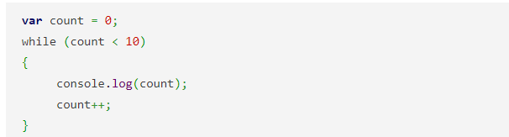

a) The values of count are logged or stored in a particular location or storage

b) The value of count from 0 to 9 is displayed in the console

c) An error is displayed

d) An exception is thrown

Answer: b

Explanation: Console.log is a predefined function in JavaScript which takes the value as an argument of its function.console.log prints this value in the argument in the console at the time of execution of the code.

88. The enumeration order becomes implementation dependent and non-interoperable if ___________

a) If the object inherits enumerable properties

b) The object does not have the properties present in the integer array indices

c) The delete keyword is never used

d) Object.defineProperty() is not used

Answer: a

Explanation: In computer programming, an enumerated type (also called enumeration or enum) is a data type consisting of a set of named values called elements, members or enumerators of the type. The enumerator names are usually identifiers that behave as constants in the language.

89. What will be the output of the following JavaScript code?

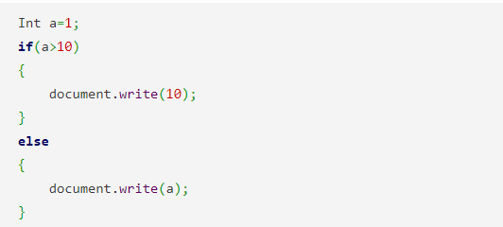

a) 10

b) 0

c) 1

d) Undefined

Answer: c

Explanation: The if else statement is a part of the javascript conditioning statements. The line of code inside the “if” statement is executed if the value passed to “if” is 1.

90. What will be the output of the following JavaScript code?

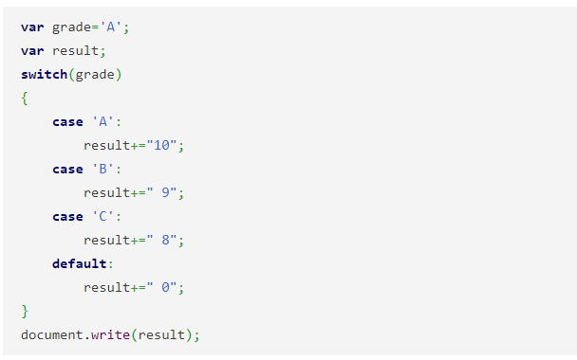

a) 10

b) 27

c) 8

d) 0

Answer: b

Explanation: The above code does not have a break statement after the cases in the switch loop. Therefore all of the cases following “A” will get executed.

91. What will be the output of the following JavaScript code?

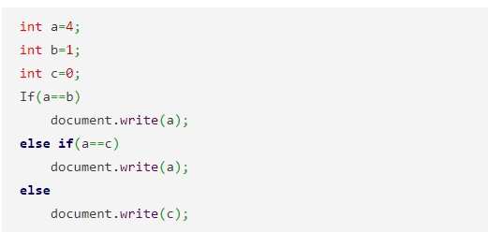

a) 4

b) 1

c) Error

d) 0

Answer: d

Explanation: For checking more than one condition the if else if loop is used. It is the extension of if else loop which is also sometimes known as if else ladder.

92. What will be the output of the following JavaScript code?

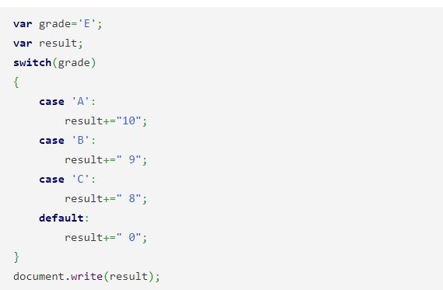

a) 10

b) 0

c) 18

d) 17

Answer: b

Explanation: The switch case contains a default case along with the other cases. The default case gets executed when no other case results into true.

93. Which function among the following lets to register a function to be invoked once?

a) setTimeout()

b) setTotaltime()

c) setInterval()

d) settime()

Answer: a

Explanation: setTimeout() and setInterval() allow you to register a function to be invoked once or repeatedly after a specified amount of time has elapsed. Both these function are used to do time manipulation in javascript.

94. Which function among the following lets to register a function to be invoked repeatedly after a certain time?

a) setTimeout()

b) setTotaltime()

c) setInterval()

d) settime()

Answer: c

Explanation: setTimeout() and setInterval() allow you to register a function to be invoked once or repeatedly after a specified amount of time has elapsed. Both these function are used to do time manipulation in javascript.

95. Which is the handler method used to invoke when uncaught JavaScript exceptions occur?

a) Onhalt

b) Onerror

c) Both onhalt and onerror

d) Onsuspend

Answer: b

Explanation: The **onerror** handler method can be registered to be invoked when uncaught JavaScript exceptions occur. The onerror event is triggered if an error occurs while loading an external file (e.g. a document or an image).

96. Which property is used to obtain browser vendor and version information?

a) modal

b) version

c) browser

d) navigator

Answer: d

Explanation: The **navigator** property is used to obtain browser vendor and version information. Various navaigator property includes appname, appversion, geolocation, language etc.

97. Which method receives the return value of **setInterval()** to cancel future invocations?

a) clearInvocation()

b) cancelInvocation()

c) clearInterval()

d) clear()

Answer: c

Explanation: Like setTimeout(), setInterval() returns a value that can be passed to clearInterval() to cancel any future invocations of the scheduled function. The ID value returned by setInterval() is used as the parameter for the clearInterval() method.

98. The **setTimeout()** belongs to which object?

a) Element

b) Window

c) Location

d) Event

Answer: b

Explanation: The setTimeout() method of the Window object schedules a function to run after a specified number of milliseconds elapses. setTimeout() and setInterval() are used for time manipulations in javascript.

99. Which method receives the return value of **setTimeout()** to cancel future invocations?

a) clearTimeout()

b) clearInterval()

c) clearSchedule()

d) cancelInvocation()

Answer: a

Explanation: setTimeout() returns a value that can be passed to clearTimeout() to cancel the execution of the scheduled function. The ID value returned by setTimeout() is used as the parameter for the clearTimeout() method.

100. What will happen if we call **setTimeout()** with a time of 0 ms?

a) Placed in stack

b) Placed in queue

c) Will run continuously

d) Will execute immediately

Answer: b

Explanation: If you call setTimeout() with a time of 0 ms, the function you specify is not invoked right away. Instead, it is placed on a queue to be invoked “as soon as possible” after any currently pending event handlers finish running.

101. To which object does the **location** property belong?

a) Window

b) Position

c) Element

d) Location

Answer: a

Explanation: The location property of the Window object refers to a Location object, which represents the current URL of the document displayed in the window. The window.location object can be used to get the current page address (URL) and to redirect the browser to a new page.

102. What will be the output of the following JavaScript code?

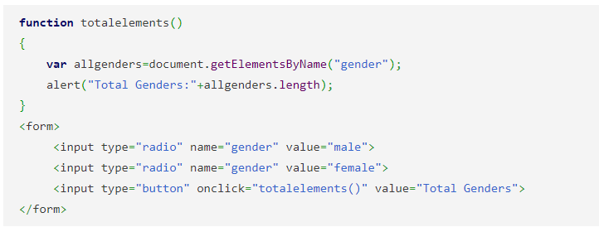

a) 0

b) Error

c) 2

d) 1

Answer: c

Explanation: The document.getElementsByName() method returns all the element of specified name. The above code counts the total number of output mentioned in the form.

103. What will be the output of the following JavaScript code?

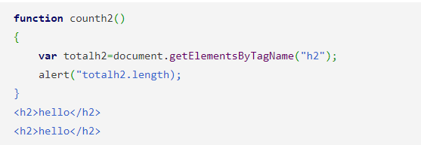

a) 0

b) hello

c) h2

d) 2

Answer: d

Explanation: The document.getElementsByTagName() method returns all the element of specified tag name. The above code counts the total number of specific tags.

104. The **URL** property belongs to which of the following object?

a) Document

b) Element

c) Location

d) Event

Answer: a

Explanation: The Document object has a URL property, which is a static string that holds the URL of the document when it was first loaded. If you want to access any element in an HTML page, you always start with accessing the document object.

105. What does the **location** property represent?

a) Current DOM object

b) Current URL

c) Both DOM object and URL

d) Document

Answer: b

Explanation: The **location** property of a window is a reference to a Location object; it represents the current URL of the document being displayed in that window.

106. Which among the following is not a property of the Location object?

a) protocol

b) host

c) hostee

d) hostname

Answer: c

Explanation: The location object is part of the window object and is accessed through the window.location property. The various properties of the location object are the **protocol, host, hostname, port, search,** and **hash**.

107. What is the return type of the **hash** property?

a) Query string

b) Packets

c) String

d) Fragment identifier

Answer: d

Explanation: The hash property sets or returns the anchor part of a URL. The hash property returns the “fragment identifier” portion of the URL if there is one a hash mark (#) followed by an element ID. It is accessed by using the statement location.hash.

108. What is the function used to extract arguments from the **search** property of a **URL**?

a) urlArgs()

b) url()

c) hash()

d) geturl()

Answer: a

Explanation: The urgArgs() function can be used to extract arguments from the search property of a URL. Search property can be accessed through the location object.

109. Which of the following can be used to select HTML elements based on the value of their **name** attributes?

a) getElementByName()

b) getElementsByName()

c) getElementsName()

d) getElementName()

Answer: b

Explanation: The getElementsByName() method returns a collection of all elements in the document with the specified name (the value of the name attribute), as a NodeList object.

**var** radiobuttons = document.getElementsByName("favorite_color");

110. Which of the following property refers to the root element of the document?

a) documentElement

b) elementdocument

c) rootdocument

d) rootelement

Answer: a

Explanation: The **documentElement** property of the Document class refers to the root element of the document. This is always an HTML element. The documentElement property returns the documentElement of the document, as an Element object.

111. The return type of **getElementsByClassName()** is __________

a) DOM

b) Document

c) Node

d) NodeList

Answer: d

Explanation: The **getElementsByClassName()** method returns a collection of all elements in the document with the specified class name, as a NodeList object. The other methods of returning nodelist objects are **getElementsByTagName()**, **getElementbyId()** etc.

112. Which of the following is the ultimate element selection method?

a) querySelectorAll()

b) querySelector()

c) queryAll()

d) query()

Answer: a

Explanation: **querySelectorAll()** is the ultimate element selection method: it is a very powerful technique by which client-side JavaScript programs can select the document elements that they are going to manipulate.

113. Which of the following is the Web application equivalent to **querySelectorAll()**?

a) #()

b) &()

c) $()

d) !()

Answer: c

Explanation: Web applications based on jQuery use a portable, cross-browser equivalent to **querySelectorAll()** named **$()**.

114. The C in CSS stands for _______________

a) Continuous

b) Cascaded

c) Contentional

d) Cascading

Answer: d

Explanation: The C in CSS stands for “cascading”. This term indicates that the style rules that apply to any given element in a document can come from a “cascade” of different sources.

115. The first version of CSS is _____________

a) CSS1

b) CSS2

c) CSS3

d) CSS

Answer: a

Explanation: The first version of CSS is CSS1. It was officially released in the year 1996.

116. Which of the following is not an example of a Shortcut Property?

a) border

b) font

c) text

d) value

Answer: d

Explanation: border, font & text are shortcut properties. For example, the font-family, font-size, font-style, and font-weight properties can all be set at once using a single font property with a compound value:

font: bold italic 24pt helvetica;

117. Which of the following is the default positioning elements with CSS?

a) relative

b) static

c) absolute

d) fixed

Answer: b

Explanation: **static** is the default value and specifies that the element is positioned according to the normal flow of document content (for most Western languages, this is left to right and top to bottom).

118. Which property lays the element according to the normal flow?

a) relative

b) absolute

c) fixed

d) static

Answer: a

Explanation: When the position property is set to **relative**, an element is laid out according to the normal flow, and its position is then adjusted relative to its position in the normal flow.

119. Which of the following property allows you to specify an element’s position with respect to the browser window?

a) relative

b) fixed

c) static

d) absolute

Answer: b

Explanation: The **fixed** value allows you to specify an element’s position with respect to the browser window. Elements with **fixed** positioning are always visible and do not scroll with the rest of the document. Like absolutely positioned elements, fixed-position elements are independent of all others and are not part of the document flow.

120. What will be the output of the following JavaScript code?

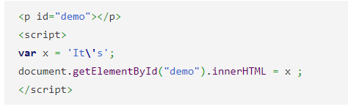

a) It\’s

b) ‘It\’s’

c) It’s

d) Error

Answer: c

Explanation: If an apostrophe is present in the string then a backslash is added before it. The string skips the execution of the character after a backslash.

121. What will be the output of the following JavaScript code?

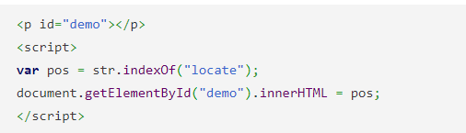

a) 5

b) 7

c) 0

d) Error

Answer: b

Explanation: The indexOf() method returns the position of the first occurrence of a specified text. locate occurs first time at 7 positions.

122. In general, event handler is nothing but ____________

a) function

b) interface

c) event

d) handler

Answer: a

Explanation: An event handler is in general, a function that handles or responds to an event. For example onclick, onkeypress, onload etc are event handler functions.

123. When will the browser invoke the handler?

a) Program begins

b) Any event occurs

c) Specified event occurs

d) Webpage loads

Answer: c

Explanation: When an event of the specified type occurs on the specified target, the browser invokes the handler. For example onclick function is executed when mouse is clicked.

124. The process by which the browser decides which objects to trigger event handlers on is ____________

a) Event Triggering

b) Event Listening

c) Event Handling

d) Event propagation

Answer: d

Explanation: *Event propagation* is the process by which the browser decides which objects to trigger event handlers. Event propagation is a way to describe the “stack” of events that are fired in a web browser.

125. Which are the events that have default actions that can be canceled by event handlers?

a) Submit and form-related events

b) Reset and form-related events

c) Submit and reset events

d) form-related events

Answer: c

Explanation: The submit and reset events have default actions that can be canceled by event handlers, and some click events do, too. The focus and blur events do not bubble, but all the other form events do.

126. The events that represent occurrences related to the browser window are _________

a) Window

b) Element

c) Display

d) Handlers

Answer: a

Explanation: Window events represent occurrences related to the browser window itself, rather than any specific document content displayed inside the window.

127. Which event is fired when a document and all of its external resources are fully loaded and displayed to the user?

a) Window

b) Load

c) Element

d) Handler

Answer: b

Explanation: The load event is the most important of these events: it is fired when a document and all of its external resources (such as images) are fully loaded and displayed to the user.

128. Which is the opposite of the load event in JavaScript?

a) dontload

b) postload

c) preload

d) unload

Answer: d

Explanation: The unload event is the opposite of load: it is triggered when the user is navigating away from a document. An unload event handler might be used to save the user’s state, but it cannot be used to cancel navigation.

129. Which is the property that is triggered in response to JavaScript errors?

a) onexception

b) onmessage

c) onerror

d) onclick

Answer: c

Explanation: The **onerror** property of the Window object is something like an event handler, and it is triggered in response to JavaScript errors. It isn’t a true event handler, however, because it is invoked with different arguments.

130. Which event can be fired on any scrollable document element?

a) Window

b) Scroll

c) Load

d) Unload

Answer: b

Explanation: Scroll events can also be fired on any scrollable document element, such as those with the CSS overflow property set.

131. When are the mouse events generated?

a) When user clicks the mouse over a document

b) When user moves over a document

c) On pressing a key

d) When user clicks or moves the mouse over a document

Answer: d

Explanation: Mouse events are generated when the user moves or clicks the mouse over a document. These events are triggered on the most deeply nested element that the mouse pointer is over, but they bubble up through the document.

132. How to detect and respond to mouse drags?

a) Registering a mouseover handler

b) Releasing a mousedown handler

c) Registering a mousedown handler

d) Releasing a mouseover handler

Answer: c

Explanation: By registering a mousedown handler that registers a mousemove handler, you can detect and respond to mouse drags. Doing this properly involves being able to capture mouse events so that you continue to receive mousemove events even when the mouse has moved out of the element it started in.

133. When is the mouseover event fired?

a) When mouse is moved over a new element

b) When mouse is clicked

c) When mouse is both moved and clicked

d) When mouse is released

Answer: a

Explanation: When the user moves the mouse so that it goes over a new element, the browser fires a mouseover event on that element. The onmouseover event occurs when the mouse pointer is moved onto an element, or onto one of its children.

134. The focus and blur events are also part of _________

a) Element events

b) Handler events

c) Window events

d) Scroll events

Answer: c

Explanation: The focus and blur events are also used as Window events: they are triggered on a window when that browser window receives or loses keyboard focus from the operating system. Focusin and onblur methods are used for using these events.

135. The element that can also register handlers for load and error events is _________

a) html

b) img

c) body

d) form

Answer: b

Explanation: Individual document elements, such as img elements, can also register handlers for load and error events.onload and onerror methods are used for handling such events.

136. Which object is passed as the argument to handlers for keydown, keyup, and keypress events?

a) KeyboardEvent

b) Key Event

c) Mouse Event

d) Alphabet Event

Answer: a

Explanation: What is new in the DOM Level 3 Events specification is standardized support for two dimensional mouse wheels via the wheel event and better support for text input events with a new KeyboardEvent object that is passed as the argument to handlers for keydown, keyup, and keypress events.

137. Which of the following property specifies the string of text that was entered?

a) message

b) data

c) string

d) text

Answer: b

Explanation: A textinput event handler has a **data** property that specifies the string of text that was entered. This data property is used for manipulating the data which is entered by the user.

138. When are the keyboard events fired?

a) When the user manually calls the button

b) When the user clicks a key

c) When the user calls the modifier

d) When the user right clicks the mouse

Answer: b

Explanation: The keydown and keyup are the keyboard events are fired when the user presses or releases a key on the keyboard. They are generated for modifier keys, function keys, and alphanumeric keys.

139. How does a user generate multiple keydown events?

a) Repeating the same process

b) Pressing multiple keys

c) Pressing the key longer than usual

d) Pressing the key multiple times

Answer: c

Explanation: If the user holds the key down long enough for it to begin repeating, there will be multiple keydown events before the keyup event arrives. Pressing the key for long time results in multiple calls to the function onkeypress.

140. Which property is used to specify the key type when pressed?

a) keyCode

b) keyType

c) keyName

d) keyProperty

Answer: a

Explanation: The keyCode property returns the Unicode character code of the key that triggered the onkeypress event, or the Unicode key code of the key that triggered the onkeydown or onkeyup event. The event object associated with these events has a numeric keyCode property that specifies which key was pressed.

141. For what value does the **keyCode** property persists even when a Shift key is pressed for adding punctuation character.

a) Special characters

b) Alphabets

c) Alphanumeric

d) Digits

Answer: d

Explanation: The number keys always generate keyCode values for the digit that appears on the key, even if you are holding down Shift in order to type a punctuation character.

142. Which of the following are not key event properties?

a) Code key

b) Alt Key

c) Ctrl Key

d) Shift Key

Answer: a

Explanation: **altKey**, **ctrlKeY**, **shiftKey**, and **metaKey** are key event object’s properties, which are set to *true* if the corresponding modifier key is held down when the event occurs. The keyCode values of ShiftKey, ctrlKey, altKey are respectively 16, 17 and 18.